Aurora's Higher Education and Research Academy
Uppal, Hyderabad, Telangana, +91 9100123456, aurora.edu.in
DEPARTMENT OF COMPUTER SCIENCE AND ENGINEERING – DATA SCIENCE
COMPREHENSIVE PROJECT REPORT

START-UP MANAGEMENT

PROJECT TITLE
CleanMilk – Building Consumer Trust through Purity Assurance
LEARNING GROUP NO: 1
INTERNAL GUIDE: Mrs. Meghna Bandi, Assistant Professor dept. of Management

NAME: M. Sai Vardhan Reddy
ROLL NO: 241U1R3001
Mob num: 9063205333
Email id: maramsaivardhanreddy@gmail.com

NAME: M. Naveen
ROLL NO: 241U1R3004
Mob num:
Email id:

NAME: K. G. Manasa
ROLL NO: 241U1R3007
Mob num: 8988199666
Email id: gmanasa125@gmail.com
Demonstration:
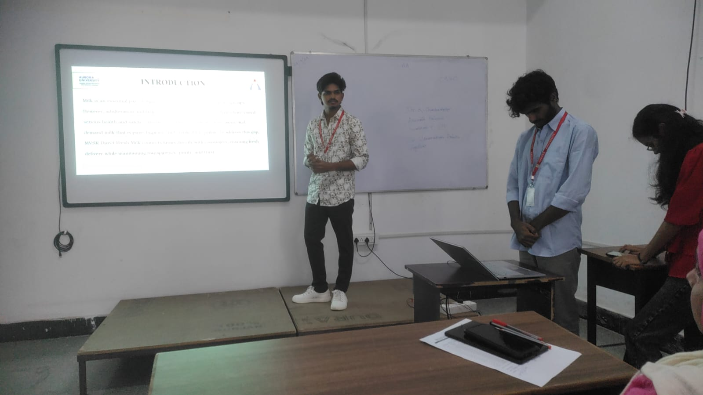

IDEA GENERATION

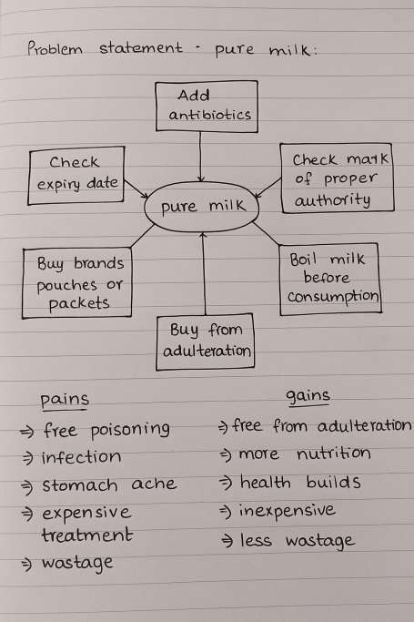

CUSTOMER PERSONA

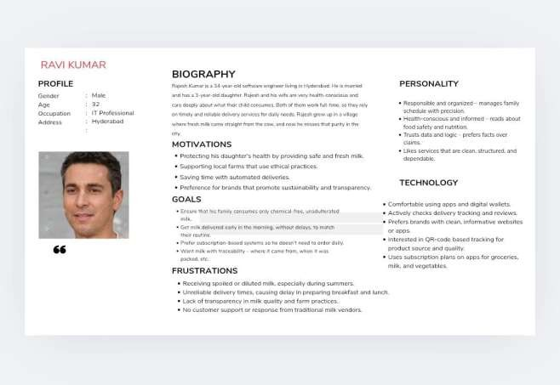

LEAN CANVAS

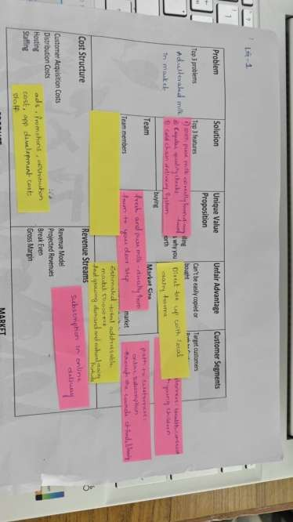

PROTOTYPE

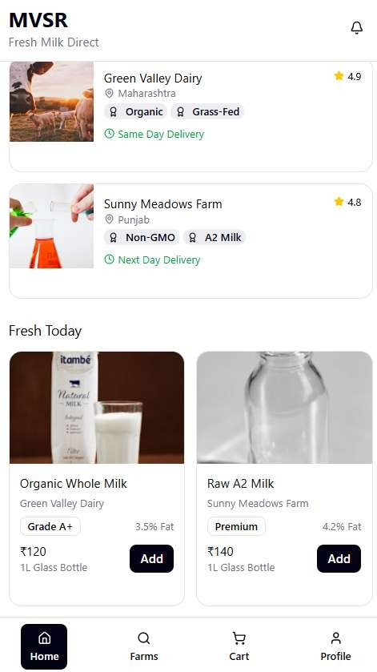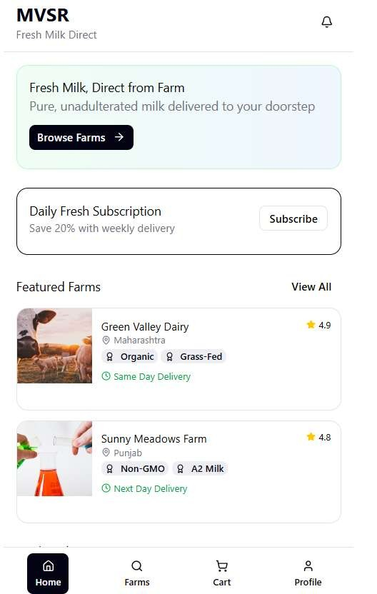

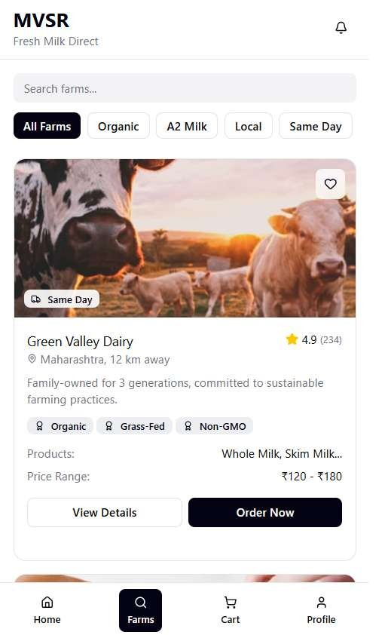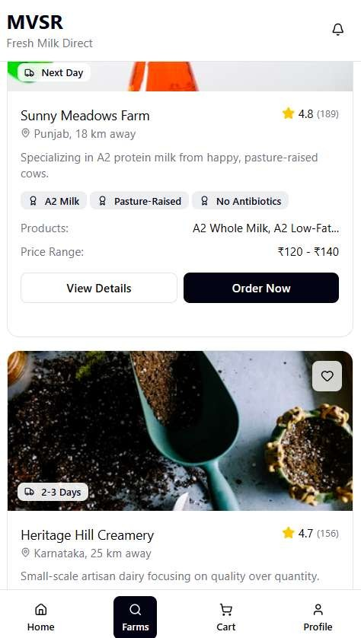

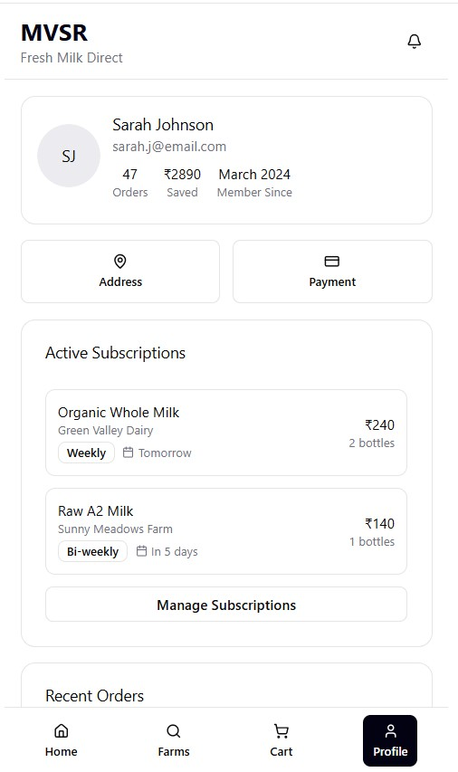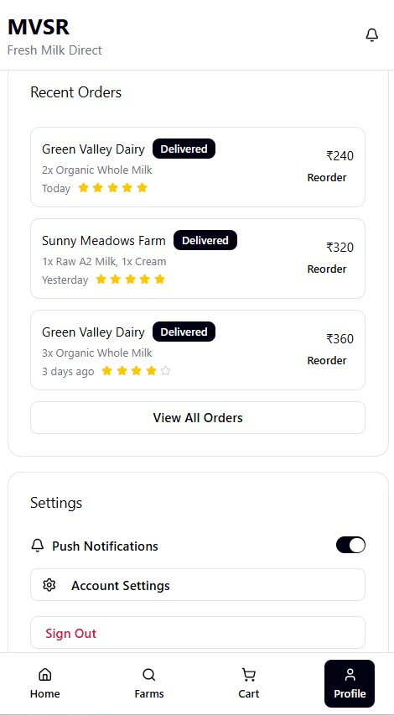

Financial Planning Tool venture of MVSR DIRECT FRESH MILK

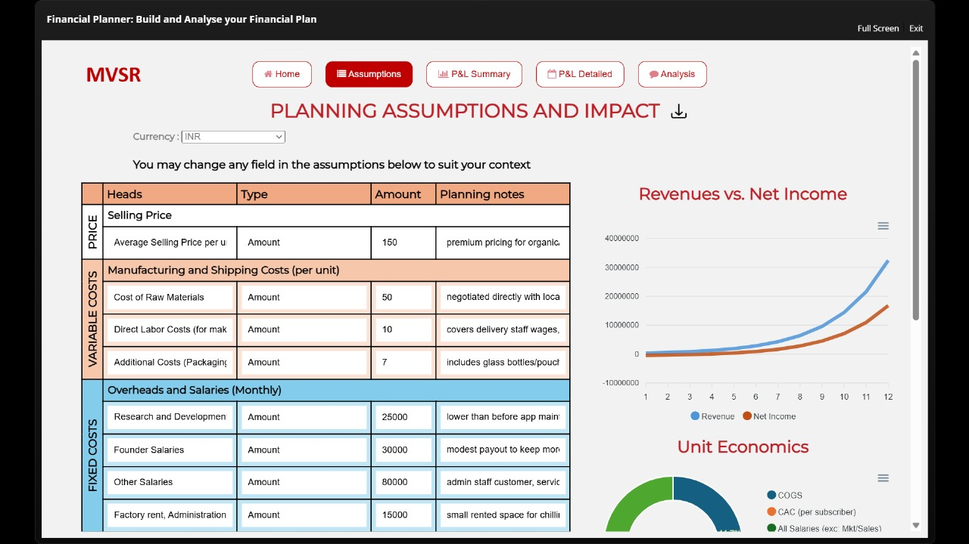
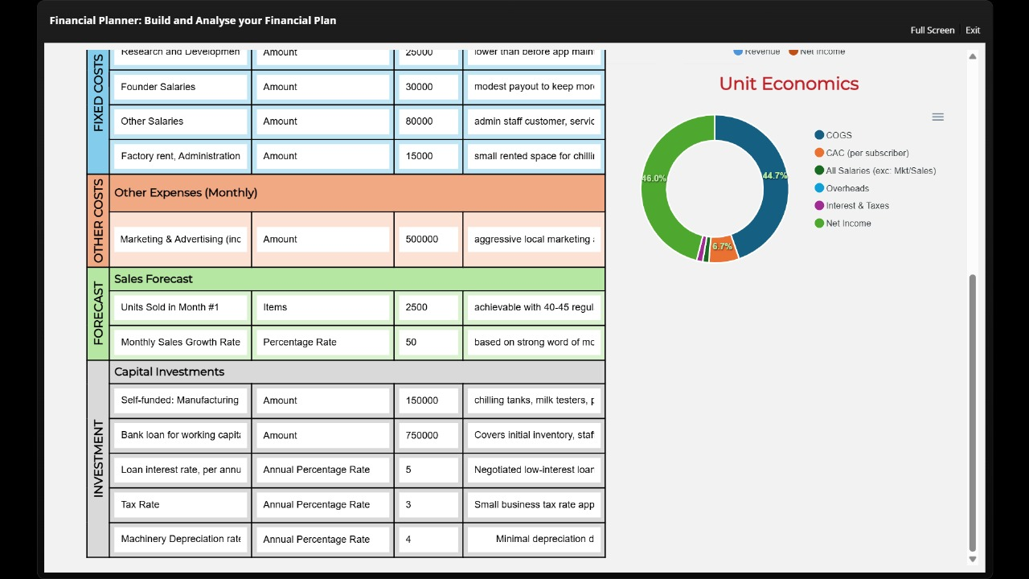

TEAM MEMBERS
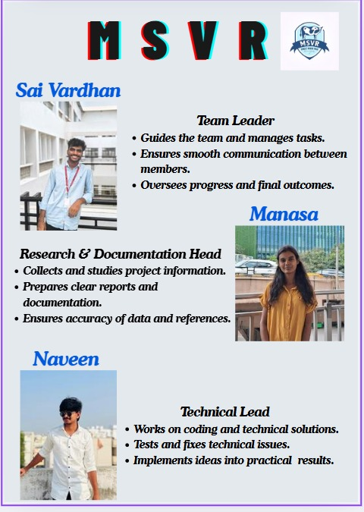

Social Media on MVSR DIECT FRESH MILK


Webpage
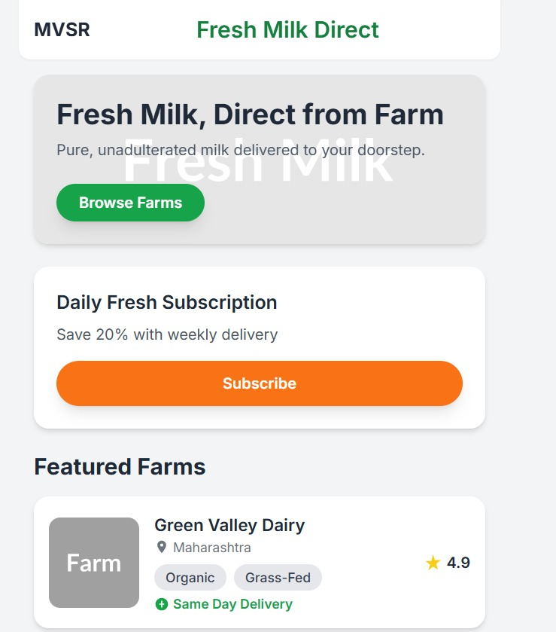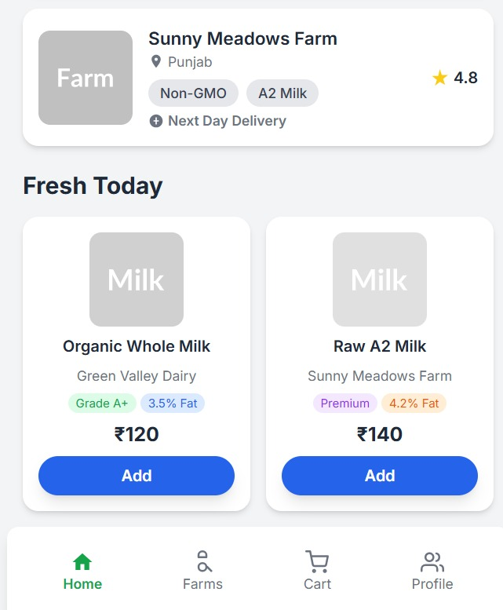

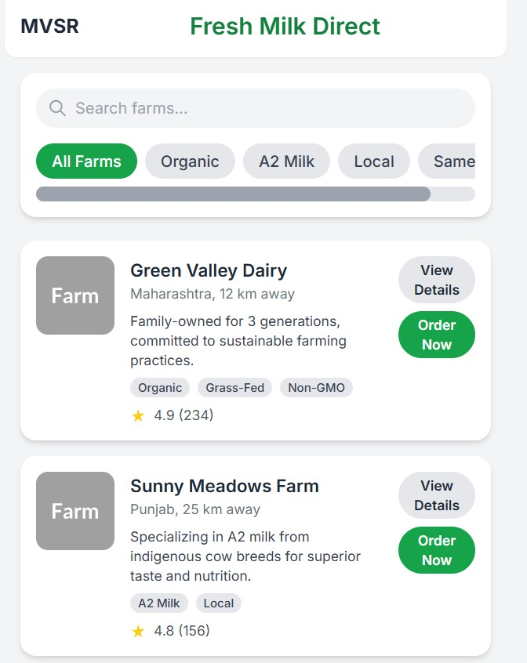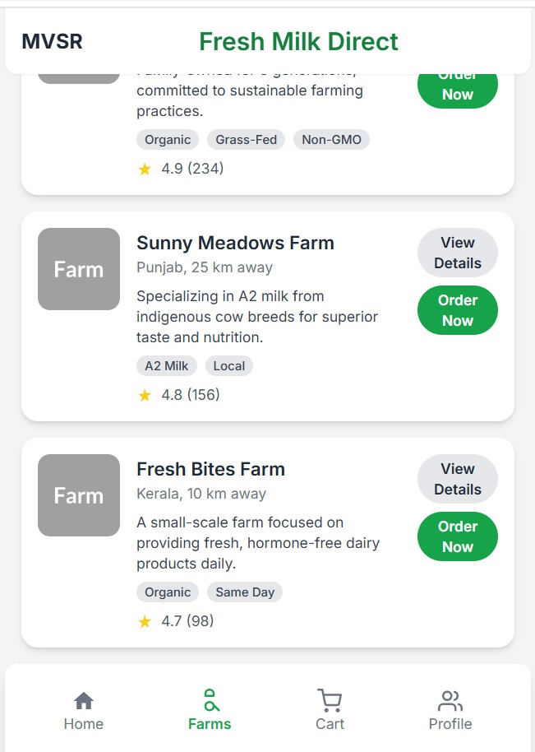

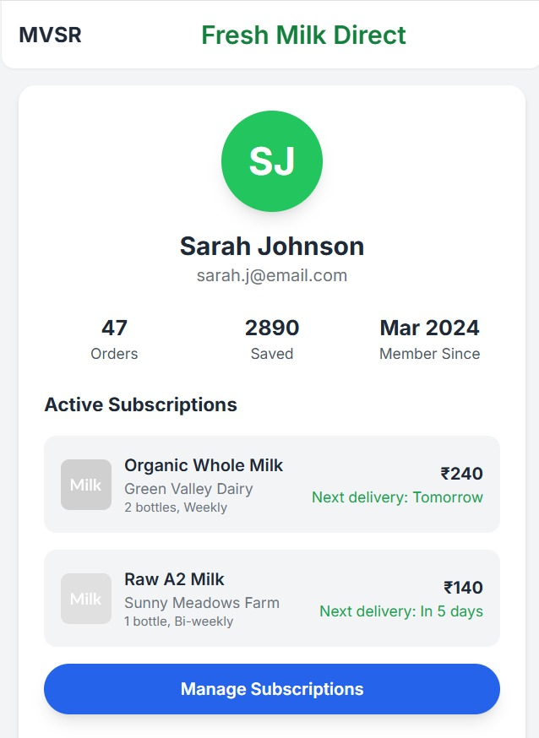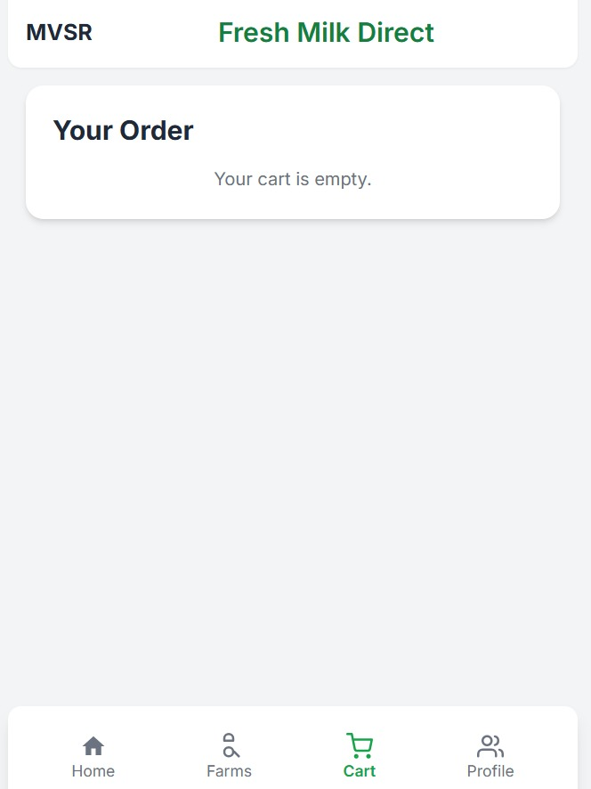
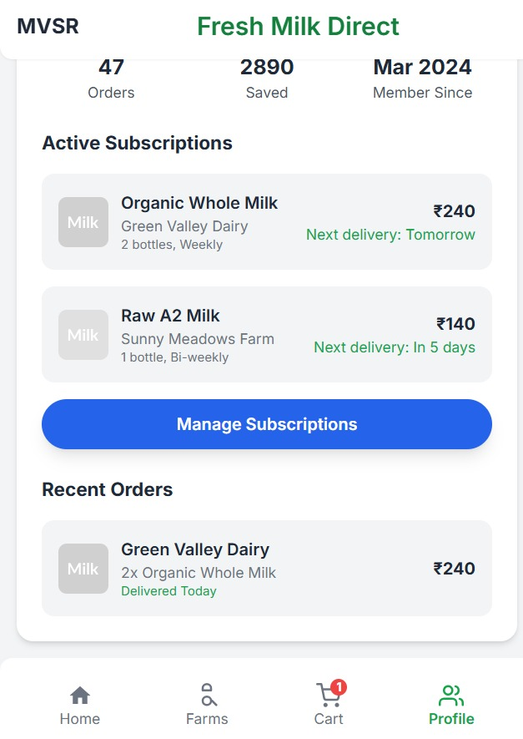
-THANK YOU-

